ECCS 1611 – Programming 1

Lab 2 – Practice with Input/Output

**Programming practice with input and output.**

Please write the following programs using Visual Studio or XCode. When completed, please demonstrate each program to either the instructor or a lab assistant. All problems are from the textbook’s Chapter 1 practice and programming project exercises. All of these projects should be placed within a subfolder (ideally, this subfolder will have a lab-related name) of your **C++Lastname-Firstname** folder that you’re sharing with me via Google Drive as a BACKUP.

**Each of the exercises below requires a separate project to be created for it. For each project, please use a name like “p2dot1” or “p2-1”; if you use the period (as in “P2.1”) within the name it will confuse Visual Studio and your program will not run, even if your code is correct!**

**Project Creation Review:**

1. Launch Microsoft Visual Studio, either by double-clicking on the appropriate desktop icon or by going to the Start button, expanding the “Visual Studio” folder, and clicking on the entry for “Microsoft Visual Studio 2019”. Create a new project by clicking on the “New Project…” link displayed on the Start Page or by selecting File > New > Project… from the menu.

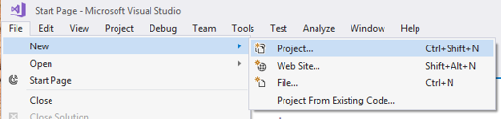

1. In the central area select “Windows Desktop Wizard”.
2. Click on the “Next”button.
3. Make sure to provide your project name and its location.
4. Click on the “Create” button.

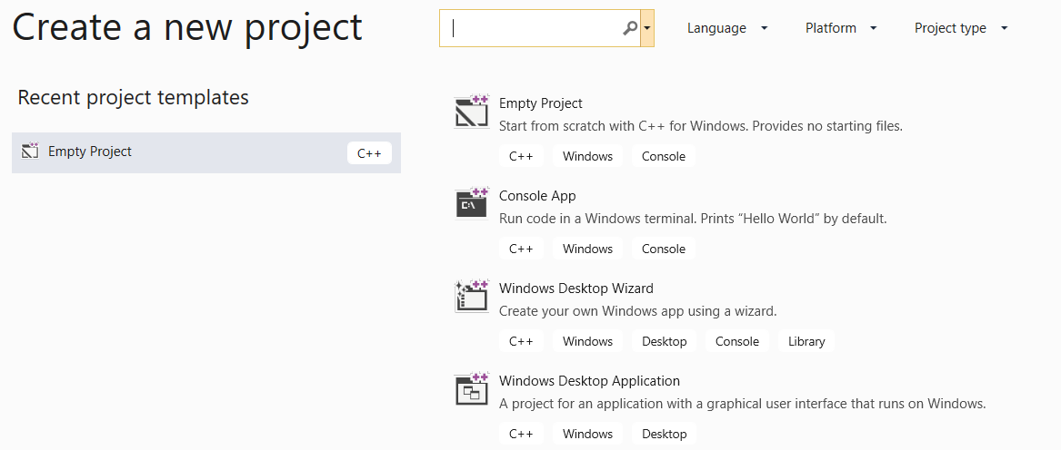

1. You’ll now see the “Windows Desktop Project” pop-up window.
2. Select “Console Application (.exe)” as the “Application type”, check “Empty Project”, and uncheck “Precompiled Header” so that the window looks like the following:

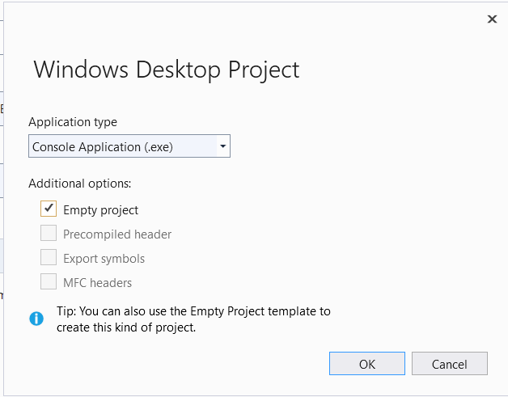

1. Click on the “OK” button and you’ll have the template that let’s your program end with the “Press any key to continue…” prompt.

P2.1 Write a program that prints out a message “Hello, my name is Hal!” Then, on a new line, the program should print the message “What is your name?” Similar to Exercise P2.1, just use the following lines of code:

string user_name;

getline(cin, user_name);

Finally, the program should print the message “Hello, *user name*. I am glad to meet you!” To print the *user name*, use the following statement:

cout << user_name;

As in Exercise P2.1, you must place the line

#include <string>

before the main function. Here is a typical program run. The user input is printed in red.

Hello, my name is Hal!

What is your name? Dave

Hello, Dave. I am glad to meet you!

P2.2 Write a program that calculates and prints the sum of the first ten positive integers. Your program must use an integer variable that is assigned this sum.

P2.3 Write a program that calculates and prints the product of the first ten positive integers. (Reminder: use the * character for multiplication in C++.)